
Lab Program Number: 30 Date: 16th March,2026
Title: Users, Groups Administration and Permission

- Create group for each department.
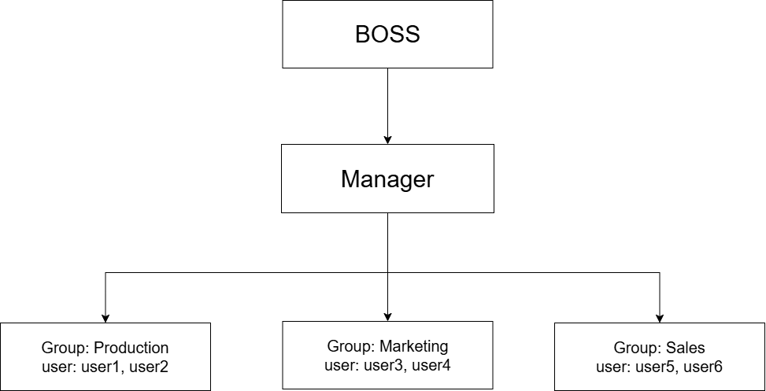
Command:
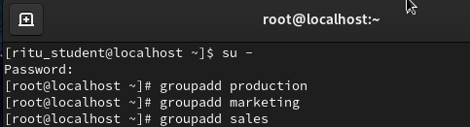
Output:
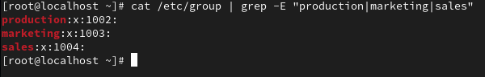

- Create user account (user1 to user6, boss, manager) for each employee asigning them respective group.
Command:
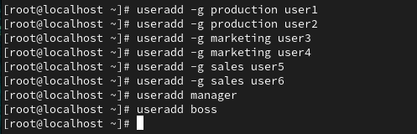

- Create common directory (/root/production, /root/marketing, /root/sales for each department.
Command:
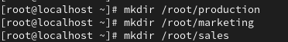

- Change ownership of group of directories such that boss will become the owner and respective groups will be group owner.
Command:
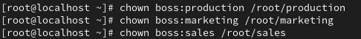

- Change the permission of the group directory such that only the owner & group member will get full.
Command:
